**MFA (Authentik) Guide**

This is a basic guide for signing in, navigating, and configuring the SSO dashboard and MFA integration. For more details, see the official [Authentik documention](https://docs.goauthentik.io/docs/).

**Prerequisites**

Before you begin, ensure you have the following:

* A stable internet connection.
* Your company issued device or a personal device that meets security standards.
* Your network credentials (username and password).

**Sign-In Instructions**

1. Navigate to the Authentik SSO login page at URL: [https://sso.kingslanding.net](https://sso.kingslanding.net/)

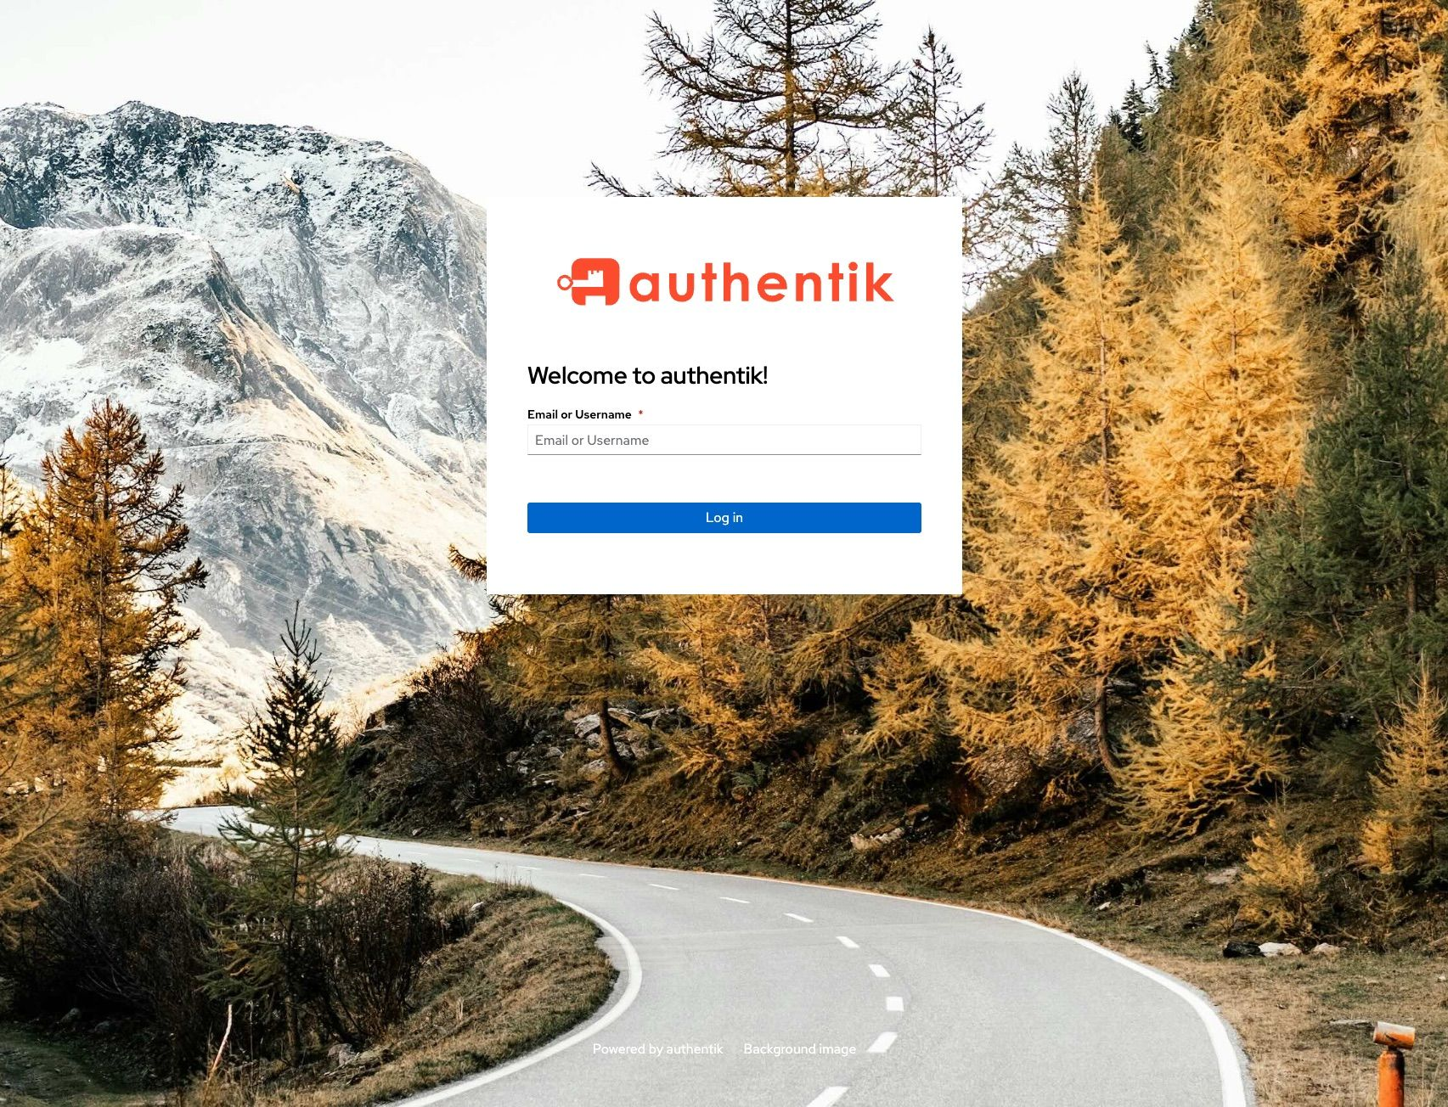

1. Enter your email or username in the designated field.
2. Enter your password in the designated field.
3. Enter your authentication token in the designated field when prompted.

**Navigating the SSO dashboard**

1. Complete the instructions above to login to the Authentik SSO dashboard.
2. You should see the applications that are integrated with Authentik on the dashboard. Navigate to your desired application and click to open it.

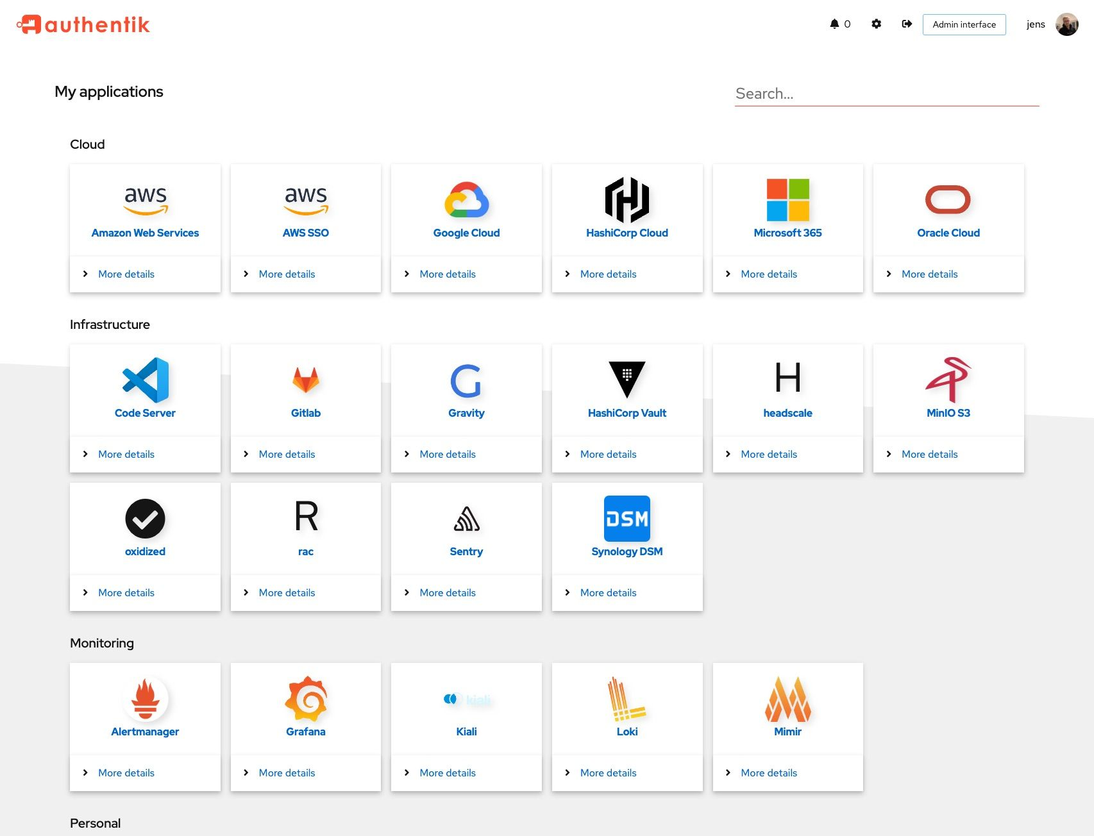

1. If you do not see your desired application, enter the name in the search bar in the top right corner and press **Enter** to search for it.

**Add New Applications & Providers**

Use the Application Wizard to add an application to your authentik dashboard and create the new application and required provider simultaneously.

1. Log into authentik as *admin*, and navigate to **Applications → Applications**.
2. Click **Create with Wizard**.
3. In the **New application** wizard, define the application details, provider type and configuration, and then click **Submit**.
4. (Optional) Define the bindins for a specific policy, group, or user to manage the display of the new application on the **My applications** dashboard page. If you do not define the bindings, all users will have access to the application.

**Configuring Secondary MFA**

1. From the SSO dashboard, navigate to **Settings** (Click the gear icon from the menu bar in the top right corner).
2. Navigate to the **MFA devices** menu
3. Select **Enroll** and the MFA device you would like to add. Then click **Continue**.
4. Confirm that the added MFA device is listed in the enabled MFA methods.